Introduction of Embedded System
1. What is an Embedded System?
An Embedded System is a specialized computer system that is designed to perform a specific task or function within a larger device or machine. It is called "embedded" because it is built inside a product and works as a part of that product.
Unlike a general-purpose computer (like a PC or laptop), which can run multiple applications and perform many different tasks, an embedded system is created for a dedicated purpose.
Definition
An embedded system is a combination of hardware and software designed to perform a specific function, often with real-time constraints.
2. Why Embedded Systems are Used?
Embedded systems are used because they provide:
- High performance for a specific task
- Low cost
- Low power consumption
- Small size
- High reliability
- Fast response time
Embedded systems are commonly used in devices where continuous and automatic operation is required.

3. Examples of Embedded Systems
Embedded systems are used in almost every field.
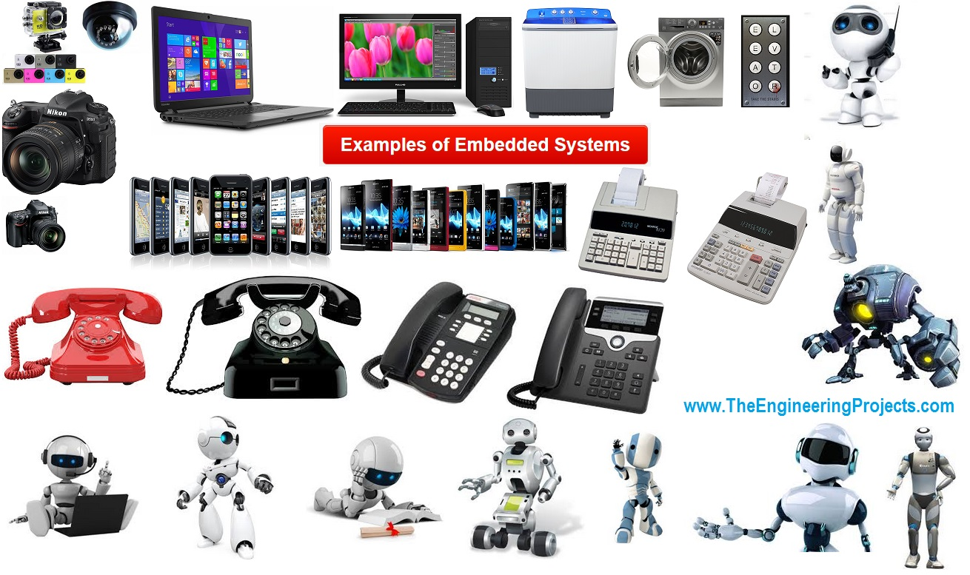
Daily Life Examples
- Washing machine
- Microwave oven
- Refrigerator
- Smart TV
- Printer
- Digital camera
- Remote control
Automobile Examples
- Airbag control system
- ABS (Anti-lock braking system)
- Engine control unit (ECU)
- Car navigation system
- Automatic gear system
Medical Examples
- ECG machine
- BP monitor
- MRI scanner
- Patient monitoring system
Industrial Examples
- Robotics
- CNC machines
- Automatic conveyor belts
- Smart sensors in factories
Communication Examples
- Routers
- Modems
- Mobile phones
- Bluetooth devices
4. Characteristics (Features) of Embedded Systems
Embedded systems have some unique features that differentiate them from normal computers.
1. Specific Functionality
Embedded systems are designed for a fixed and specific task.
Example: A washing machine embedded system only controls washing cycles.
2. Real-Time Operation
Many embedded systems work under real-time constraints.
Example: Airbag deployment must happen instantly.
3. Small Size
They are compact because they are built inside devices.
4. Low Power Consumption
Most embedded systems operate on battery power, so power saving is important.
5. High Reliability
They must work continuously for long periods without failure.
6. Limited Memory and Processing
Embedded systems generally have limited storage and RAM compared to computers.
7. Cost Efficient
They are designed with low-cost hardware to reduce product cost.

5. Basic Structure of an Embedded System
An Embedded System is mainly made up of two major parts:
1. Hardware
Hardware means the physical components of the embedded system which you can touch and see.
Hardware includes:
(a) Microcontroller / Microprocessor
- This is the main brain of the embedded system.
- It controls all operations.
- Example: 8051, PIC, AVR, ARM, Arduino (ATmega328), ESP32
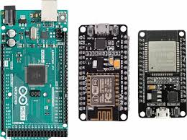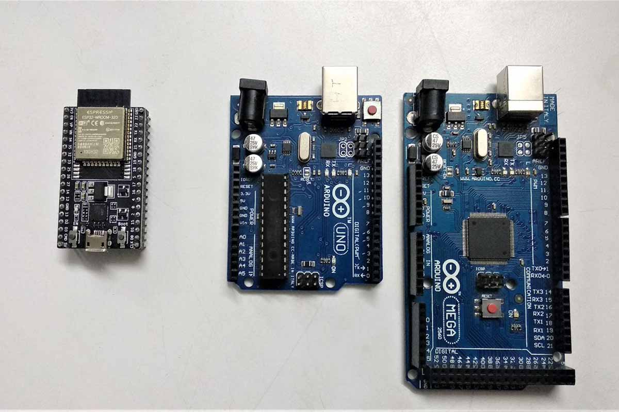
(b) Memory (Embedded System) – Detailed Notes (English)
In an embedded system, memory is used to store the program (firmware) and data required for system operation. Memory is a very important part because it decides how the system stores code, processes information, and performs tasks.
Embedded systems mainly use two types of memory:
- ROM / Flash Memory (Non-Volatile Memory)
- RAM (Volatile Memory)

1. ROM / Flash Memory (Non-Volatile Memory)
Meaning:
ROM (Read Only Memory) or Flash Memory is a type of memory that stores data permanently.
Key Point:
Even if the power supply is turned OFF, the stored program/data remains safe.
Use in Embedded Systems:
ROM/Flash memory stores the firmware, which is the main program that controls the embedded system.
What is stored in ROM/Flash?
- Firmware (main program code)
- Bootloader (startup code)
- Permanent settings
- Calibration values
- Default configuration data
Example:
When you upload code into a microcontroller (Arduino, STM32, PIC, etc.), the program is stored in Flash memory
Types of ROM
1. Mask ROM
- Program is stored by the manufacturer
- Cannot be changed by the user
2. PROM (Programmable ROM)
- Can be programmed only once
- Cannot be erased
3. EPROM (Erasable PROM)
- Can be erased using UV light
- Can be reprogrammed
4. EEPROM (Electrically Erasable PROM)
- Can be erased and programmed electrically
- Used for storing small permanent data
5. Flash Memory
- Advanced form of EEPROM
- Faster and has larger storage capacity
- Most common memory used in microcontrollers
Features of Flash Memory
- Non-volatile (data remains stored)
- Used for permanent storage
- Supports firmware updates
- Reliable and widely used

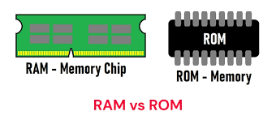
2. RAM (Volatile Memory)
Meaning:
RAM (Random Access Memory) is a memory used to store temporary data while the program is running.
Key Point:
When power is turned OFF, all data in RAM is erased.
Use in Embedded Systems:
RAM stores the data required during program execution, such as variables, sensor readings, and intermediate calculations.
What is stored in RAM?
- Variables (int, float, char, etc.)
- Sensor readings (temperature, pressure, etc.)
- Temporary calculations
- Buffers (UART buffer, ADC buffer, etc.)
- Stack memory (function calls, local variables)
- Heap memory (dynamic memory allocation)
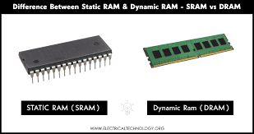
How Memory Works in an Embedded System
Step-by-step Working:
- The firmware is stored permanently in Flash/ROM.
- When the system starts, the processor reads instructions from Flash.
- During execution, temporary data is stored in RAM.
- When power is turned OFF:
  - Flash/ROM retains the program
  - RAM loses all stored data
Feature | ROM / Flash Memory | RAM
Data Storage | Permanent | Temporary
Power OFF Effect | Data remains stored | Data is erased
Speed | Slower than RAM | Faster
Used For | Program/Firmware storage | Running data storage
Example | Firmware, boot code | Variables, buffers
Type | Flash, EEPROM | SRAM, DRAM

Why Both ROM and RAM Are Needed?
ROM/Flash is needed because:
- Program must be stored permanently
- Firmware should remain safe even after power OFF
RAM is needed because:
- Program needs fast memory for execution
- Temporary calculations and sensor data must be stored during operation
Real-Life Example (Easy Understanding)
Example: Washing Machine Embedded System
Stored in Flash/ROM:
- Washing programs (normal, quick wash)
- Motor control logic
- Water level control code
Stored in RAM:
- Current water level value
- Timer value
- Temporary sensor readings
- Intermediate calculations
If power goes OFF:
- The program remains safe in Flash
- Running data stored in RAM is lost
(c) Input Devices (Sensors / Switches)
Used to take input from the environment.
Examples:
- Temperature sensor
- IR sensor
- Keypad
- Button switch
- Light sensor (LDR)
(d) Output Devices (Actuators / Display)
Used to give output.
Examples:
- LED
- LCD display
- Motor
- Buzzer
- Relay
(e) Communication Interfaces (Embedded System) – Detailed Notes
In an embedded system, Communication Interfaces are used to transfer data between the embedded device and other devices such as sensors, computers, controllers, displays, memory chips, and networks.
These interfaces help the system to send and receive information in the form of signals or digital data.
Communication interfaces can be divided into two main categories:
- Wired Communication Interfaces
- Wireless Communication Interfaces

1. UART / Serial Communication (Universal Asynchronous Receiver Transmitter)
Meaning:
UART is a very common communication method used in microcontrollers for serial communication.
Features:
- Asynchronous communication (no clock signal required)
- Uses only two main lines
  - TX (Transmit)
  - RX (Receive)
- Also uses GND for reference
Working:
Data is transmitted bit by bit along with:
- Start bit
- Data bits (5 to 9 bits)
- Optional parity bit
- Stop bit
Speed:
Common baud rates:
9600, 19200, 115200 etc.
Advantages:
- Simple and low cost
- Easy to use for debugging
- Works with computers and modules
Disadvantages:
- Short distance communication
- Not suitable for high speed compared to SPI
Applications:
- Bluetooth module communication
- GPS modules
- Serial monitor debugging (Arduino)
- GSM modules

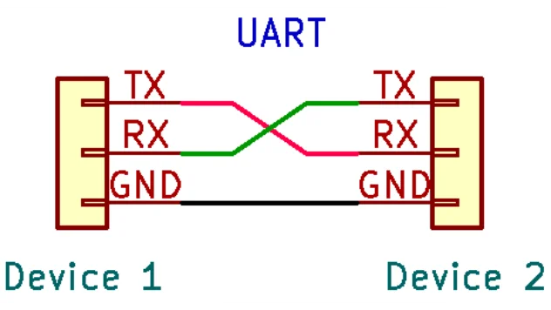
2. SPI (Serial Peripheral Interface)
Meaning:
SPI is a synchronous serial communication protocol used for high-speed data transfer between microcontroller and peripherals.
Features:
- Uses a clock signal
- Full duplex communication (data can send and receive at same time)
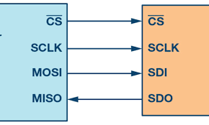
SPI Pins:
SPI uses 4 main pins:
- MOSI (Master Out Slave In)
- MISO (Master in Slave Out)
- SCLK (Serial Clock)
- SS/CS (Slave Select / Chip Select)
Working:
- One device is Master (microcontroller)
- Other devices are Slaves (sensors, memory, display)
Advantages:
- Very fast communication
- Simple hardware design
- Full duplex
Disadvantages:
- Requires more wires
- No built-in addressing (needs separate CS pin for each device)
Applications:
- SD cards
- OLED/LCD displays
- Flash memory chips
- ADC/DAC modules

3. I2C (Inter-Integrated Circuit)
Meaning:
I2C is a serial communication protocol used to connect multiple devices using only two wires.
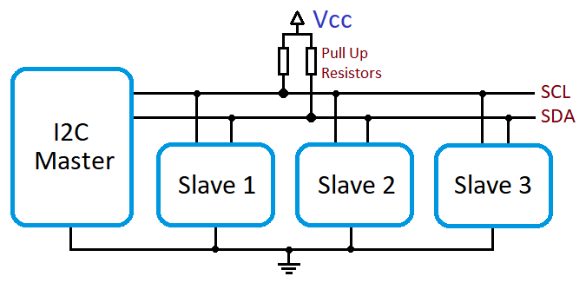
Features:
- Synchronous communication
- Supports multiple devices on the same bus
- Each device has a unique address
I2C Pins:
- SDA (Serial Data Line)
- SCL (Serial Clock Line)
Working:
- Master generates clock
- Slave responds according to address
- Supports multiple masters and multiple slaves
Speed:
Standard I2C speeds:
- 100 kbps (Standard mode)
- 400 kbps (Fast mode)
- 1 Mbps (Fast mode plus)
- 3.4 Mbps (High speed)
Advantages:
- Uses only 2 wires
- Supports multiple devices
- Easy to expand
Disadvantages:
- Slower than SPI
- Needs pull-up resistors
- Limited distance
Applications:
- RTC (Real Time Clock)
- EEPROM
- Sensors (temperature, pressure)
- IMU sensors (gyro, accelerometer)
4. CAN (Controller Area Network)
Meaning:
CAN is a communication protocol mainly used in automobile and industrial systems.
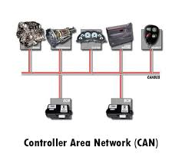
Features:
- Very reliable
- Supports multiple controllers on one network
- Uses differential signaling (CANH and CANL)
CAN Lines:
- CAN High (CANH)
- CAN Low (CANL)
Working:
- All devices connected on a common bus
- Messages are broadcast
- Priority based communication (message ID decides priority)
Advantages:
- High reliability
- Error detection and correction
- Suitable for noisy environments
- Long distance communication
Disadvantages:
- More complex than UART/I2C
- Requires CAN controller/transceiver
Applications:
- Car ECU communication
- ABS system
- Airbag control
- Industrial automation

5. USB (Universal Serial Bus)
Meaning:
USB is a high-speed communication interface used to connect embedded systems with computers and peripherals.
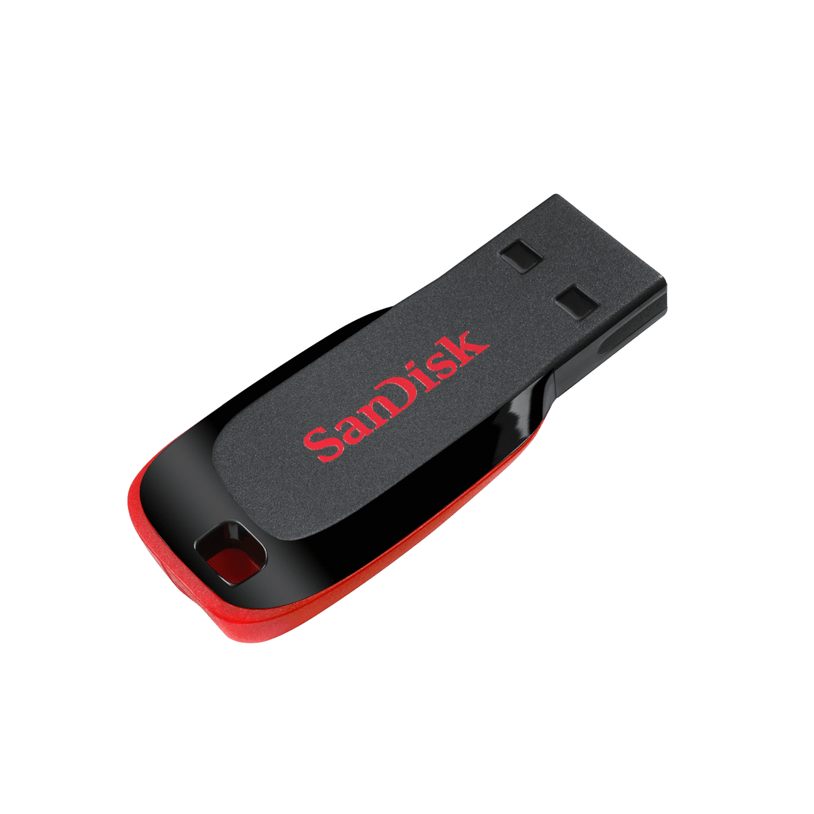
Features:
- High data transfer rate
- Supports power supply and communication together
- Plug and play interface
USB Modes:
- USB Device mode (embedded device acts as device)
- USB Host mode (embedded system controls other USB devices)
Advantages:
- High speed communication
- Widely supported in computers
- Provides power and data both
Disadvantages:
- Complex protocol
- Requires more software and driver support
Applications:
- USB keyboards and mouse
- Pen drives
- Embedded data loggers
- Mobile charging and data transfer

6. Wi-Fi (Wireless Communication)
Meaning:
Wi-Fi is a wireless communication technology used for internet and network-based communication.
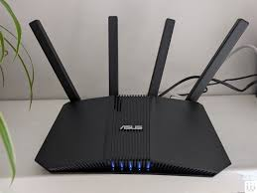
Features:
- Uses radio waves
- Provides wireless LAN connection
- Long range compared to Bluetooth
Advantages:
- High data speed
- Internet connectivity
- Supports IoT applications
Disadvantages:
- Higher power consumption
- More costly than Bluetooth
- Security issues if not configured properly
Applications:
- Smart home devices
- IoT sensors
- Remote monitoring systems
- Smart cameras

7. Bluetooth (Wireless Communication)
Meaning:
Bluetooth is a wireless communication method used for short-range data transfer.
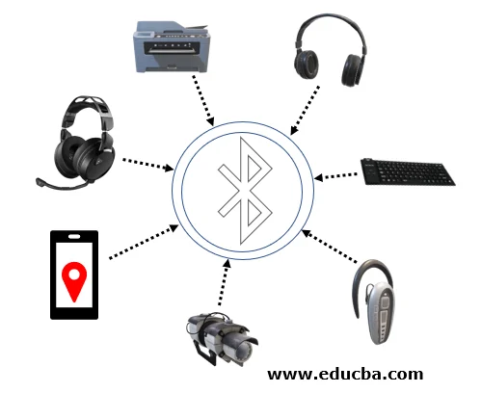

Types:
- Classic Bluetooth (audio, file transfer)
- BLE (Bluetooth Low Energy) – low power version
Advantages:
- Low power consumption (BLE)
- Cheap and easy to use
- Suitable for short range communication
Disadvantages:
- Low range compared to Wi-Fi
- Slower speed than Wi-Fi
Applications:
- Wireless headphones
- Fitness bands
- Mobile-controlled devices
- Smart locks

Wired vs Wireless Communication
Feature | Wired (UART/SPI/I2C/CAN/USB) | Wireless (Wi-Fi/Bluetooth)
Speed | Medium to high | High (Wi-Fi), Medium (Bluetooth)
Range | Short to medium | Medium to long
Power | Low to medium | Higher (Wi-Fi)
Cost | Low | Medium
Reliability | High | Depends on signal

(f) Power Supply
- Provides required voltage to system.
- Example: Battery, adapter, SMPS, regulator (7805)
(g) Clock / Oscillator
- Provides timing signals to the processor.
- Example: Crystal oscillator (8 MHz, 16 MHz)
2. Software :
Software means the program code that runs inside the embedded system to control the hardware.
- Software in embedded system is also called:
Firmware
Software includes:
(a) Embedded Program / Application Code
- Written in C, C++, Assembly, Embedded Python, etc.
- Controls sensors, outputs, display, etc.
- Example tasks:
- Read temperature sensor
- Turn ON fan if temperature is high
- Display temperature on LCD
(b) Device Drivers
- Drivers are programs that help microcontroller communicate with hardware devices.
- Example:
- LCD driver
- Motor driver
- Sensor driver
(c) Operating System (Optional)
- Some embedded systems use an OS.
- Types:
RTOS (Real Time Operating System) like FreeRTOS
- Embedded Linux
- Many small systems do not need OS (bare-metal programming).
(d) Compiler / Debugger Tools
- Used to write and test the program.
- Examples:
- Keil
- MPLAB
- Arduino IDE
- STM32CubeIDE

